**How to add source files in Qt projects**

Author: Rafael Guimaraes de Paula

**Add a .cpp source file in project**

Let's consider that we have a project without any source file. The only file that you can find inside the project folder is the .pro file, where all the configuration is stored about the Qt framework.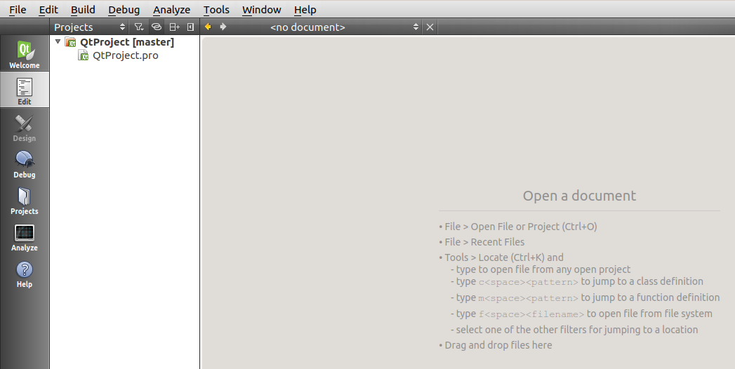

Let's add a main.cpp file in the project. Right-click on the project and select “Add New...”.

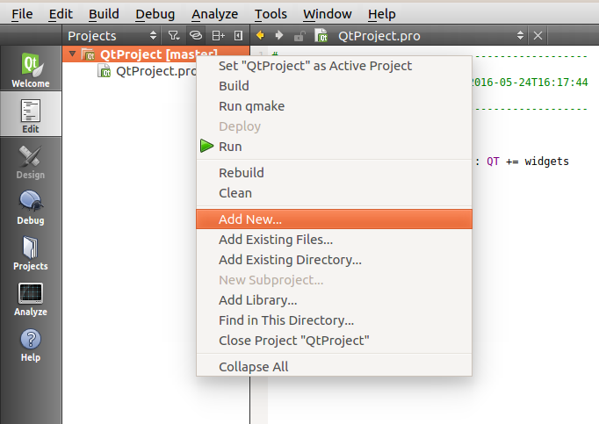

Select C++ Source File. Click “Choose...”

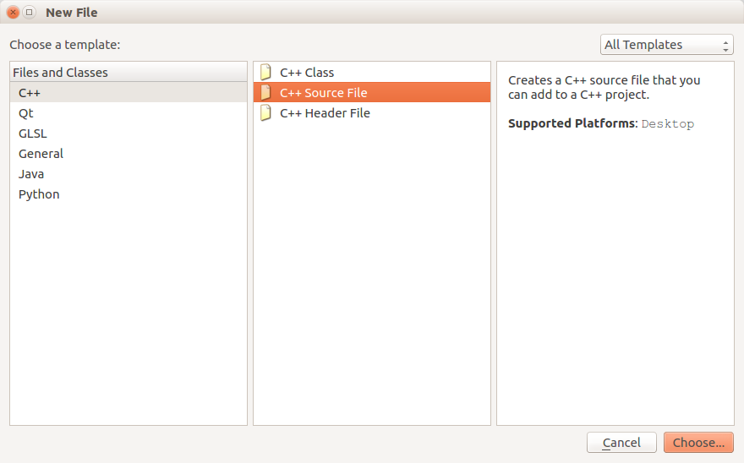

Choose the name of the source file and Click “Next>” and then “Finish”. After this, the file has been added to the project. Check that the .pro file has been automatically modified to the project recognize the new source file added. This will happen to all the source, headers and form files added to the project.

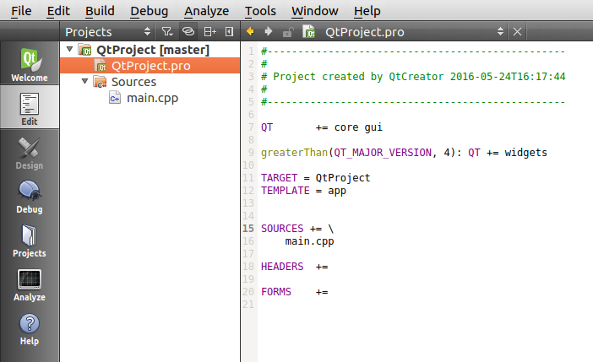

**Add a class header and source file in project**

Right-click on the project and select “Add New...” the same way as in the previous example. Now choose “C++ Class” and click “Choose...”

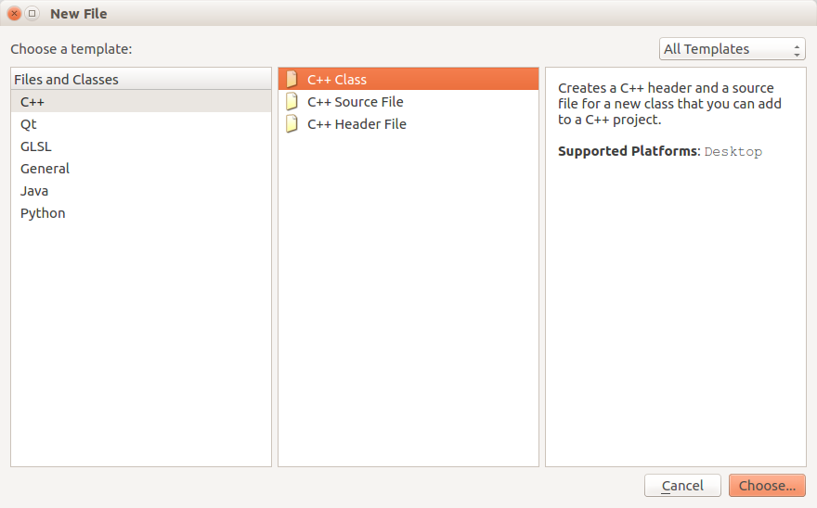

Choose the class name. The header and source files will have the same name. Click “Next>” and “Finish”. Both header and source file from the class will be added to the project.

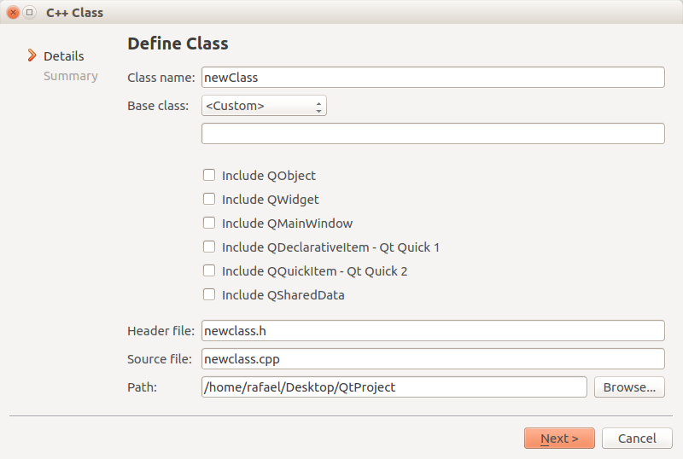

**Add a designer form class in project**

Right-click on the project and select “Add New...” the same way as in the previous example. Now choose “Qt Designer Form Class” and click “Choose...”.

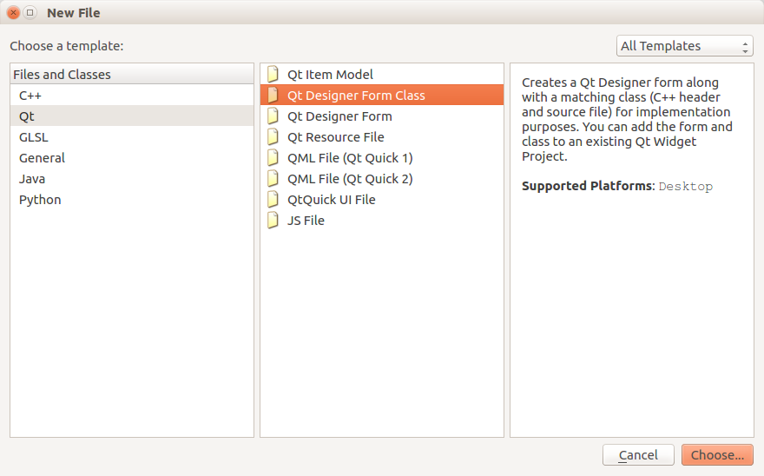

Choose a template for your interface application. Click “Next>”.

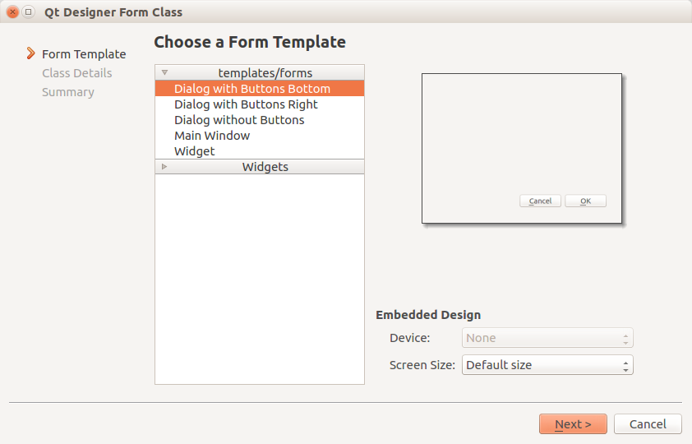

Choose the name of the UI (User Interface) form class. This will be the same name as the source and header files. Click “Next>” and then “Finish”.

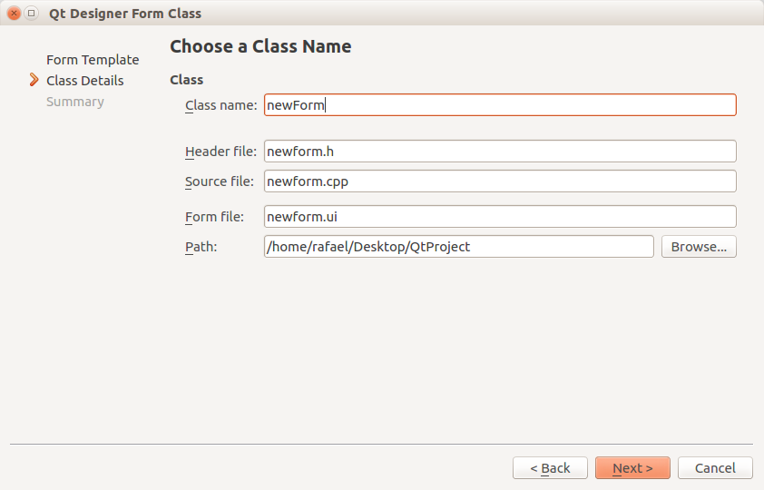

You will be directly redirected to the UI designer mode, where you can drag and drop elements to your form. To return to the code editor mode, press Ctrl+2 or click “Edit” on the left side of the window.

